Physics 10L – Rick Nolthenius, Instructor for Fall 26
Your Name _________________________________________

LAB 1:Linear Motion and Freefall

Read Hewitt Chapter 3
What to learn and explore
A bat can fly around in the dark without bumping into things by sensing the echoes of squeaks it emits. These squeaks reflect off walls and objects, return to the bat’s head, and are processed in its brain to provide the location of nearby objects. The automatic focus on some cameras works on very much the same principle. The motion sensor we will be using in this lab is a device that measures the time that ultra high frequency sound waves take to go to and return from an object. As the object moves, the change in its position is measured many times each second. The change in position from moment to moment is expressed as a velocity (meters per second, m/s). The change in velocity from moment to moment is expressed as an acceleration (meters per second per second, written m/s²). The position of an object at a particular time can be plotted on a graph. You can also graph the velocity and acceleration of the object versus time. In this lab, you will work with graphs of position and velocity in real-time, that is, as the motion is happening.

Several of the experiments below give you an opportunity to distinguish between velocity and acceleration. These two terms are often confused. Remember, velocity is speed with direction, but acceleration is a change in velocity--that is, speeding up, slowing down, or turning. Try to apply your understanding of acceleration to observations of the freefall motion of balls or other objects tossed in the air. Is it really true that the acceleration of an object due to gravity is constant and always downward? What effect does the acceleration of gravity have on the horizontal motion of an object?

What to use
Balls, strobe video camera, large-screen monitor, flashlight, computer, motion sensor, Pasco Capstone, spark timer.

What to do
There are suggested experiments starting on the next page to help you answer the questions on the sheet and other questions of your own. Be sure to (a) read about the experiment and make predictions in writing before making observations, (b) discuss your predictions with your lab partners, and (c) compare your observations with predictions. With your partners, try to agree or at least agree to disagree about your individual predictions and observations.

Mandatory Comments
When you finish the lab, please write a few comments here. (For example: what was the most interesting experiment, and why?)

1) Strobe Images and motion diagrams: Velocity and Acceleration

After a class discussion on strobe images and motion diagrams, sketch diagrams that illustrate the following situations:

a) An object moving with constant velocity.
b) An object that accelerates in the same direction as its velocity (Hint — we call this speeding up!). Draw arrows to show the directions of the velocity and acceleration.

c) Sketch a motion in which the acceleration is opposite to the velocity (Hint — this is called slowing down). Include arrows to show the directions of the velocity and acceleration.

d) Produce and sketch a motion in which the acceleration is sideways to the velocity (Hint — this is called turning!). Include arrows to show the directions of the velocity and acceleration.

e) Sketch a motion diagram that illustrates a combination of two of the above types of motion (i.e an object that is changing speed and direction at the same time).

2) Freefall – video on computer
What does the strobe image of a falling ball look like? Open the file ball_down.trk in the Tracker program located on the Newton drive (\\newton\Labs\Physics-Lab\Experiments\Physics10 Lab\Motion Diagrams\tracker files)

a) What is the direction of its velocity?

b) What is the direction of its acceleration?

Observe a ball thrown straight up (ball_up.trk)

c) What is the direction of the velocity for a ball thrown straight up?

d) What is the direction of the acceleration for a ball thrown straight up?

e) Sketch and summarize your observations and conclusions below.

3) Ball Tossed in an Arc
Look at this strobe image of a tossed ball:
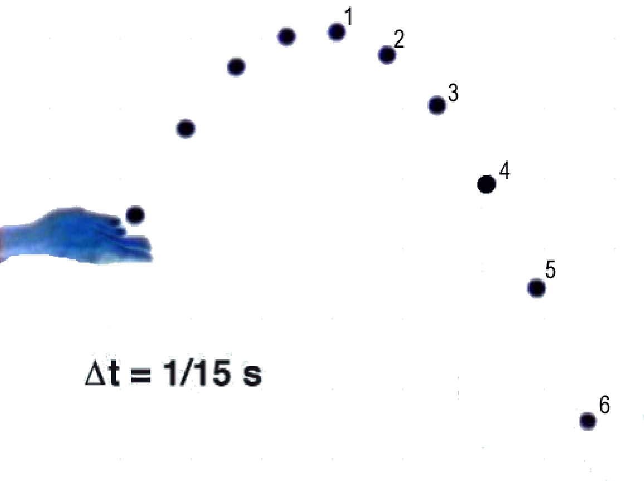

a) Make a prediction: If you drew a horizontal line through each of the strobe images of the ball, how will the vertical spacing between the lines change as the ball falls from its highest point? Make a sketch showing your prediction for the spacing of these lines.

b) Now draw horizontal lines through the balls in the picture. Do they match your prediction?

c) Make another prediction: What will it look like if you draw vertical lines through the ball's positions? In particular, how will the horizontal spacing between the lines change as the ball falls from its highest point? Make a sketch showing your predictions below.

d) Now draw vertical lines through the balls in the picture. Does it look like what you predicted? Discuss your observations below. What can you conclude about the horizontal motion of the ball? Are you pleased to discover how simple it is? Is there a “wow” here?

4) Horizontal and Vertical Motion – are they connected?
Study the gizmo that allows you to drop a ball vertically and shoot a ball horizontally at the same time.
Will the falling ball accelerate? If so, in what direction?

Will the ‘shot’ ball accelerate? If so, in what direction?

Which ball will hit the ground first? Why?

Now try it out a few times. Did the behavior agree with your predictions? If not, how was it different?

With your lab group, create your own simple “law of physics” that describes the relationship between the horizontal and vertical motions of balls falling on earth.

5) Motion Sensor: Position vs. Time
Place the motion sensor on the lab table so that its beam is about chest high. The motion sensor has a minimum range of about .1 m (10 cm). Readings at distances closer than 0.1 meters will be erratic. You will be moving forward and backward in this part of the lab, so clear a space behind you of about
2 - 3 meters.

- Open the file “Physics 10 Motion Games” and go to the tab: Position vs Time

The computer will show you a graph of your motion. Play around with it enough so that you understand what the graph is telling you – you will need to understand it for the next part.

Try moving forward and away from the sensor, moving slowly and quickly, etc., to see how the graph changes. To test your understanding, have one of your lab partners close their eyes while someone creates a graph. See if that person can tell you what you did just by looking at the graph.

- Now go to the tab “Position Game Easy”. Sketch the red graph below.

Describe the motion represented by the graph in words (i.e. standing still for 3 seconds, moving forward quickly for 2 seconds, …). How much room will you need to recreate this graph?

Have each member of your group try to reproduce the graph using the motion detector. After clicking the record button you will have two seconds to get to the starting position. Write each group member’s score below. Feel free to practice!

- Now open the tab “Position Game Harder”

Describe the motion represented by the graph in words (i.e. standing still for 3 seconds, moving forward quickly for 2 seconds, …).

Have each member of your group try to reproduce the graph using the motion detector.

6) Motion Sensor: Velocity vs. Time

In this part of the lab, you will be looking at velocity vs. time rather than position vs. time.

First, to get a sense of how fast things move in meters/sec, measure the walking speed of one of your lab partners with a stopwatch and tape measure.
What is their walking speed? _________ m ÷ __________ sec = __________________ m/s *

(*Hint: think about how many digits to include in your final answer – do you really know your speed to within a thousandth of a meter/sec?)

- Open the tab→ Velocity vs Time
Play around with the graphs again until they make sense to everyone. Try moving forward, backwards, fast, slow, and standing still.

Have someone close their eyes while you make a graph and see if they can describe what you did by looking at the graph.

- Open the tab: Velocity Game 1. Sketch the red graph below.

Describe the motion represented by the graph in words (i.e. standing still for 3 seconds, moving forward quickly for 2 seconds, …). How fast are the velocities on this graph compared to your walking speed?

Have each member of your group try to reproduce the graph using the motion detector. Write each group member’s score below.

c) !!Challenge!! Open the tab→ Velocity Game 2
Describe the motion represented by the graph in words (i.e. standing still for 3 seconds, moving forward quickly for 2 seconds, …).

Have each member of your group try to reproduce the graph using the motion detector.

7) Spark Timer: Freefall
Use a spark timer and spark tape to record the position of a freely falling metal ball. It makes 60 sparks per second, so it records the position about twice as fast as a movie camera.

Instructions for equipment:
-make sure the knob is turned to ‘off’
-attach a paper tape to the full length of the metal rod
-hang ball from magnetic post (you may have to move it around till it sits right)
-turn the knob on the large box to “LINE’
- press and HOLD the small red ‘release’ button – hold it the whole time the ball is falling

Just by looking at your tape, describe how the distance between marks changes as the ball approaches the ground. Did you expect this pattern? What does it tell you?

a) Put the tape on a lab bench, skip the first mark, and then circle the next 21 consecutive marks. Number these marks 0, 1, 2, …

b) Carefully measure the distance in centimeters from marks 0 to 1 and determine the ball’s speed in centimeters/’tick’. Repeat for marks 5 to 6, etc. Write your data in the table below. . (If you want to convert the speeds into cm/sec, remember that each ‘tick’ is 1/60 sec. If you don’t want to, no problem.)

 | marks 0 - 1 |  | marks 5 -6 |  | marks 10 -11 |  | marks 15 - 16 |  | marks 20 - 21
Distance
Average Speed
Change in speed

c) Does the speed change by nearly the same amount in each of your ‘5 tick’ intervals?
What does this tell you about the acceleration of the falling ball?

d) Challenge: The acceleration due to gravity in the absence of air resistance should be 980 cm/s². (This is the same as 9.8 m/s²) If you’re interested, you can get the acceleration due to gravity from your velocity data in part b. (hint: each of the velocity changes you observed took five clicks, or 5/60 second)

Conclusion:
It took literally hundreds of years for scientists to clearly sort the concepts of velocity and acceleration. If you have managed to get it clear in your mind, you are doing great. Please write your own definitions of velocity and acceleration below.
velocity:

acceleration:

Go back to the first page of this lab and write your comments. Then bring the lab to the instructor for a quick check before you leave the lab.

