Physics 10L – Rick Nolthenius, Instructor for Fall 26
Your Name _________________________________________

LAB 10: Music and Noise

Read Hewitt Chapters 20 and 21
What to learn and explore
Most of the sounds we hear are noises. Slamming doors, rustling of papers, creaking of floors, and most of the sounds from traffic in city streets are noises. Noise corresponds to the irregular vibration of the eardrum produced by some irregular vibration of some object. The sound of music, however, tends to be regular and repeat itself. Of course, the line that separates music from noise is thin and subjective.
Sound waves can be produced by many different kinds of oscillators: simple oscillators that produce only a single frequency, standing wave oscillators that produce multiple but related frequencies (fundamental and harmonics), and more complicated oscillators that produce many unrelated frequencies—including the random frequencies we call noise. We will learn to distinguish and describe these frequencies by looking at a sound's frequency spectrum, which is a graph that shows the frequencies present in the sound and their corresponding amplitudes.
Vocabulary for this lab: frequency, pitch, octave, amplitude, loudness, chord, fundamental, harmonic.

What to do
Do the experiments starting on the next page to help answer the questions posed and other questions of your own. Whenever possible, (a) read about the experiment and make predictions before making observations, and (b) discuss your predictions and observations with your lab partners to make sure you all agree or agree to disagree. However, note that in this lab you will be making many discoveries that do not lend themselves to prediction until after you have played with the equipment for a while.

Mandatory Comments
When you finish the lab, please write any thoughts and comments you have on today’s experiment here. Thank you.

1) Waveforms and Frequency Spectra
If you analyzed several different kinds of vegetable juice, you might make a graph to describe how much of each kind of vegetable was in each one. Since most sound waves are made up of more than one frequency, we create graphs to tell us how much of each separate frequency is included in the sound we hear. This experiment will show you how it works.

a) Use the Sound Analyzer website (https://johnw.org/physicsapps/soundLab.html) to study the relationship between the frequency, amplitude and wave shape. Play with the controls in “Create a Sound by Adding Frequencies” for a little while and see how the program works. You can change the base frequency (called the fundamental) and you can add different amounts of higher frequencies (twice the base freq, 3x the base freq, etc) with the +/- buttons. Notice how these things change the wave shape and frequency spectrum. You can click “Play Sound” to make the computer play the sound you have created.

Draw examples that you create.

A sound with a large amplitude and low frequency:
waveform | frequency spectrum

A sound with a small amplitude and high frequency:
waveform | frequency spectrum

A sound with 2 different frequencies:
Waveform | frequency spectrum

A sound with 3 different frequencies:
waveform | frequency spectrum

It is much easier to draw and read a frequency spectrum than it is to draw and read a waveform! For this reason, you will draw only the frequency spectra of the sounds you listen to in the rest of this lab.

b) Shown below are two different waveforms. With your lab partners, try to reproduce each waveform (roughly, not exactly) Draw the corresponding frequency spectrum in the spaces below.

Hints: The first waveform is a combination of two waves, the second is a combination of three waves.

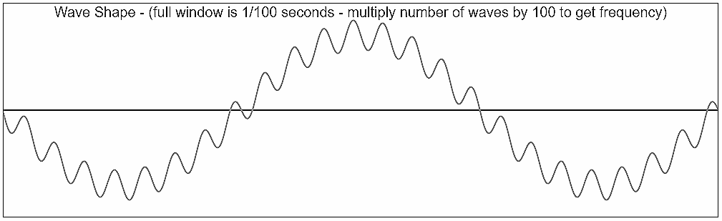

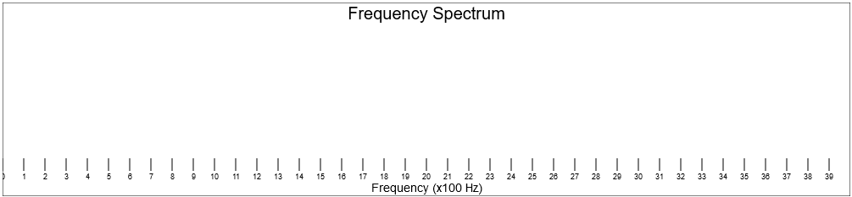

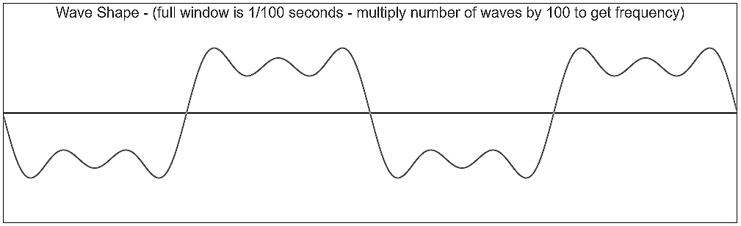

c) Play these sounds to your lab partner using the headphones, in a random order. See if they can tell which one you are playing, the one with 3 frequencies or the one with 2 frequencies.

Were they able to hear the difference?

What clues did they use?

2) Whistle
Now you’ll use a microphone to analyze your own sound. Click “Start Microphone” and “Freeze Microphone” to show the wave shape and frequency spectrum of your own sounds.
Try whistling into the microphone, and then freeze the screen when you have a good note going.
Look at both the waveform and the frequency spectrum.
Whistling tends to produce a ‘pure’ note, meaning it has only one frequency. From looking at your frequency spectrum, do you find this to be true? (Hint: look for large bars in the frequency spectrum, and ignore little fuzzy stuff at the bottom.)

What is the main frequency of your whistle?

What are the lowest and highest notes (frequencies) your group can whistle?

Can you make a whistling sound that isn’t a pure note? Can you hear the difference?

Make a simple sketch of the waveform and frequency spectrum of one of your ‘pure’ whistle sounds:

Whistle
waveform | frequency spectrum

3) Recorder

Now blow into the recorder and see how the spectrum compares to a whistle.
(Pick only one person to be the recorder player for sanitary reasons.)
You’ll get the best sound if you cover all the finger holes to start with.
Have someone click stop while you have a good note going. Draw what you observe.
(Remember to just draw the main features, not every single tiny bar).

Recorder
waveform | frequency spectrum

You will see more than one frequency this time. The lowest (left most) frequency in a group like this is called the ‘fundamental’ frequency. The fundamental is the frequency we associate with a particular note.
What is the fundamental frequency of this note on the recorder?

Frequencies higher than the fundamental are called ‘harmonics’. List the harmonic frequencies you see in the spectrum of the recorder note.

What relationship(s) do you see between the harmonic frequencies and the fundamental frequency?

How is this similar to what you saw on the string and the spring in the Waves lab last week?

Play with different notes, etc. and see if you can discover anything fun and interesting.

4) Voice

Now try singing a note into the mic. Look for your fundamental frequency and harmonics.

Try to sing the ‘purest’ note you can (a note where the ‘harmonics’ aren’t very big). Sketch it below:

Singing voice
waveform | frequency spectrum

Is the fundamental frequency the loudest (tallest) frequency in this case? If not, which one was?

Try to make a sound with lots and lots of strong harmonics. What did it sound like?

Have two people try to sing the same note (one at a time). See if you can see a difference in their frequency spectra. Do you think a computer could be programmed to tell the difference between your voice and your lab partner’s voice?

Which do you think would be better at telling voices apart, a computer, or your brain?

Try saying different vowel sounds, like “aaay” “eeee, “iiiii”, “ooh”, or “uuuu”? Try to keep all the sounds at the same “note”. For your voice, which vowel sound has the strongest harmonics?

Which is the ‘purest’?

5) Musical Instruments
- Play a note on a musical instrument. Can you identify the fundamental (lowest) frequency in its spectrum? Sketch the frequency spectrum here.

b) Are harmonics (higher frequencies) present in the spectrum? How many? Which are loudest?

- Now that you’re getting good at looking at frequency spectra, try some experimenting. Play some other notes, play the instrument differently (pluck the string differently, blow harder or softer, etc.) From the sounds you hear, try to predict how the frequency spectrum will change, then look at the spectrum to see how it matches your prediction. Make a sketch of an interesting thing you found.

How was this spectrum made? Describe what you did to produce it.

How is it different from the spectrum in part (a)?

- You can recognize different instruments even when they are playing the same note, because they have different frequency spectra—that’s the reason we have different kinds of instruments ☺.
Play the same note on 2 different instruments and then draw and compare their spectra. (Hint: Get help if you need it to find the same note on 2 different instruments. The guitar and the banjo work well.)
Spectrum 1. Which instrument?____________________
Spectrum 2. Which instrument?____________________

What similarities are there between the two spectra? What are the main differences in the two spectra? How would you describe the differences in sound between the two instruments?
6) Music to our ears -- Synthesizer.

a) Simultaneously play the keys marked with red. Next play the keys marked with green. Which combination sounds more pleasing? Do you all agree about this?

Certain combinations of notes are called chords. These are groups of notes with specific relationships between their frequencies. Some are pleasing to the ear, others may not be. Perhaps certain chords sound good because they mimic natural harmonics. There is, as usual, a whole lifetime of study here.

b) Play two or three keys at the same time on the keyboard. Can your ear pick out the individual tones? Test your partner by having them close their eyes and tell you how many notes you are playing (1, 2, or 3). Ears are pretty cool, aren’t they? Remember this activity when you get to the lab about light. You’ll see if our eyes work the same way, or not.

c) To play a musical scale on the keyboard, play the white keys from C to C. How does the frequency of the high C compare to that of the low C? Use the sound analyzer to find out. In music, two notes this far apart are called an ‘octave’. Can you tell why it’s called an octave from the keyboard? (Hint: count the number of white keys from C to C.)

d) Play a couple of other “octaves,” such as E to E or G to G. Use the computer to find the simple relationship between the frequencies of two notes that are an octave apart.
Note we used = ____ . Fundamental frequency = _____________
Same note an octave higher: fundamental frequency = ______________
How do those two frequencies compare?

Try again with a different note:
Note we used = ____ . Fundamental frequency = _____________
Same note an octave higher : fundamental frequency = ______________
How do those two frequencies compare?

Write down a general rule about the frequencies of notes that are an octave apart.

7) Noise

a) What does the spectrum of a hiss look like? What about a “sh” sound? Rubbing hands together? Clapping? Barking or snarling like a dog? Other ‘non-musical’ sounds? Sketch (and label) the frequency spectrum of a couple of the sounds.
Spectrum of… ____________________
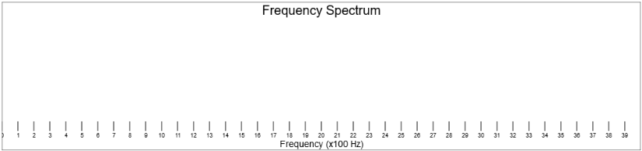
Spectrum of …____________________
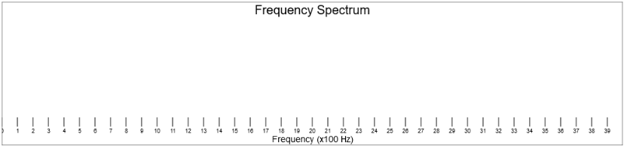

b) What do the spectra of these “noises” have in common? How are they different from the spectra of musical sounds? Remember these noise spectra – we’ll talk about them again in the lab on light and color.

8) Canceling Noise Out
Devices have been developed that can create pressure waves that are opposite to the noise in a room, canceling it out to produce a very pleasant quiet. We have such a device. It is an electronic box with headphones and an on-off switch.

First turn the switch off, put on the headphones and listen to the room noises. Then turn on the switch. After a pause, the device will turn on.
a) What happens? Cool?

9) What frequencies can you hear?
A book will tell you that "people can hear in the range from 20 to 20,000 Hz", but that is just a generalization. In this activity, you'll find out the highest frequency you can hear. Go to the website http://onlinetonegenerator.com/hearingtest.html and use headphones to find out the highest frequency you can hear. (Don’t click the big green button, but instead the little play button on the slider.)

Write down the highest frequency you can hear ____________.

10) Wrap-up
Musicians often use the words “pitch” and “loudness”. Now that you’ve learned some physics vocabulary, what physics words correspond to these “music words”?

