Physics 10L – Rick Nolthenius, Instructor for Fall 26
Your Name _________________________________________

LAB 12: Reflection and Refraction
Read Hewitt Chapter 28
Why this lab?
Beauty is a fundamental pleasure, wherever it occurs, but can you even imagine a world without light? Visual experiences of beauty would be absent from our lives, and it might also be challenging to see where we are going or what we are doing. Cherish your senses and the ways they connect you to the world!
Today we look again at the glory of light, and some of the ways we enhance what we see. From eyeglasses to magnifying glasses to telescopes and microscopes, we enrich our lives.
Light travels in straight lines if left alone. We will use pure laser light to show this. Then we will see that we can bounce light off surfaces, bend it through the atmosphere, or bend it as it goes from one material into another. In each of these ways, we can change its path. This leads us to some useful tools, such as prisms, mirrors, and lenses. We'll meet these today.
Light bounces off mirror surfaces-this is called reflection. Examples are bathroom mirrors, fun-house mirrors, or telescopes. Mirrors can fool you, because the eye is very easily fooled: your brain assumes all the light came into your eyes in straight lines. We'll look at images in flat mirrors, and mirrors curved in different ways. We will see images that only exist in our mind, and other images that we can project on a wall.
White light, as studied last week, is composed of many colors. When white light encounters a change in the medium (like entering air from glass or glass from air) it changes direction. This is refraction. Each color bends a different amount. This property is called dispersion, and it leads to lovely rainbows!
If we make a lens (that could almost be a clever stack of prisms), we can change the direction of the light coming from an object, and we produce images either on a screen or in your brain! There are many uses for lenses: a simple magnifying glass, a projector, your eye (with a lens that can change shape), complex cameras with a computer-designed stack of lenses, and more.

Part 1. LIGHT GOES STRAIGHT (demo)
We will do a demonstration with lasers and fog, and briefly discuss what is really straight (curved space?). On our human scale, light beams are pretty darn straight. Since nothing is straighter, we use light beams as our definition of "straight."

Part 2. REFLECTION Light "bounces” off mirror surfaces:
- Plane (FLAT) Mirror
Look at your image in the plane mirror. Note that your image is located behind the mirror. You can see it, and it looks very real, but you cannot project it on a screen. This kind of image is called a "virtual" image.

- Ask a partner to stand behind the mirror, off to the side, so that it looks like he or she is standing right next to your image.
Measure (on the floor) the distance from you to the mirror, and from the mirror to your partner.
Is your image as far behind the mirror as you are in front of it? Move closer or farther and check again. Record your numbers.

- Measure the height of your image by having your partner (who is still standing behind the mirror next to your image) hold a vertical 2 meter stick, and you tell them where to point their finger at the top of your image's head. How does the height of your image compare with the height of you, the “object”?

- The image-to-object ratio is called the "magnification," so if the image and object are the same size, the magnification is 1. If the image is twice as big as the object, the magnification is 2. What is the magnification in this case?
Plane Mirror magnification : __________________
Switch places with your partners so everyone sees this and “gets” it.

- Fun-house Mirror(s): When mirrors are not flat, they make images that are changed.
Play with our fun-house mirror and try to imagine how the light is being reflected to fool your eye.
- Convex mirror: (bulges outward)
  - Look at the back of a shiny spoon. Move it toward and away from you. What do you see?

- Find the BIG convex mirror, Walk toward it, then walk away, observe and describe what happens. Where do you see these mirrors? What is their purpose on the roads and in markets?

- Concave mirror: (curves inward, like a cave)

- Look at the inside of a shiny spoon. See yourself? Right side up, or inverted?_________Move it toward you. What happens when you get really close?

- Find the BIG concave mirror – put your face into it – scary? This is a magnifying mirror or shaving mirror. You have to be close to the mirror to see your face upright. Move away slowly. Keep moving away, until about ten feet or more. Summarize what happens along the way.

- Images from a Concave mirror: Face a small shaving mirror toward a distant bright object and see if you can focus an image on a piece of paper. (Hold the paper off to the side so you don't block the mirror with your paper). Move the paper in and out until you find and focus the image. Notice that the image forms at a specific distance from the mirror. If the paper is too close or too far away from the mirror, the image will be fuzzy or nonexistent. Note that here the image is located in front of the mirror, and it projects on a screen, 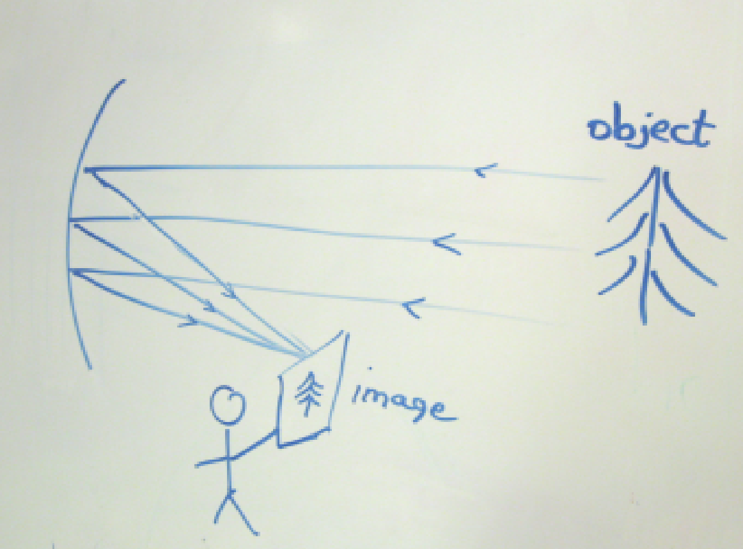so this is a "real" image.

Roughly how far is the sharp image from the mirror? This is the focal length ƒ of the mirror.

approximate f = _________________

Is the image right side up or inverted? ____________

- Ghost light bulb: Sit on the stool and look at the "ghost" light bulb floating in space above the socket. Go put your hand through it.
Is there light on your hand? ______________________
Is the bulb really there? _________________________
Is its image really there? ________________________
This is an example of a “real” image, with real light there. Wander around a bit to see where you can see this image, and where you cannot. Is this image right side up? _______ (a trick question-look inside the box before you answer)

Part 3 REFRACTION Light changes direction when it goes from one medium to another—and, by the way, the colors change different amounts…

- Prism with white light: Just have fun with this. Lots of good information in the Hewitt textbook about rainbows and all the pretty colors you can separate out of white light.

- Lenses How do we make a lens? It's a clever stack of prisms. Each bends the light in such a way that the lens either spreads (diverges) or pinches together (converges) the light rays.

Use lens kits (blue boxes) to play with the behavior of lenses and curved mirrors. Make simple freehand sketches of the rays in each of the four cases:
Concave Mirror

Convex Lens

Convex Mirror

Concave Lens

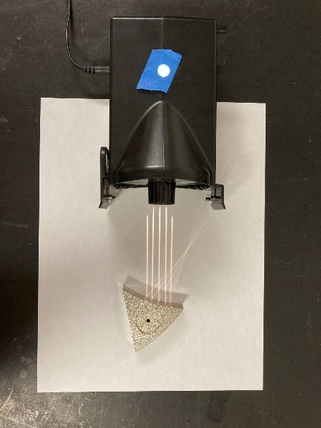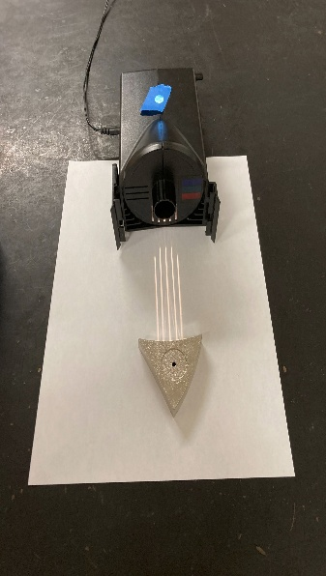
Note: The spot where incoming parallel rays meet, after passing through a lens or reflecting off a mirror, is called the focal point. If the rays are converging (coming together), you can see the focal point easily. If the rays are diverging (spreading out), you need to trace them back to where they would have come from.....that is the focal point. Show the focal point on each of your 4 sketches. Which of these 4 can make an inverted image?
** What do you predict would happen if you stacked the concave and convex lenses together? Try it.
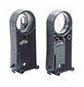
- Very distant object – focal length

Use these lenses ->>

Use a convex lens to form a clear image―on a screen-of a distant bright object.
Approximately how far is the image from the center of the lens? This is the focal length of the lens.

Choose a different convex lens and do this again. Which lens made the bigger image?

Why do you think photographers pay big bucks for lenses with long focal lengths?

- Magnifying Glass
Hold a convex lens very close to this piece of paper and read this: what's up?
Move the lens very slowly away from the paper. What happens to the image?

How far from the paper can you hold the lens and still read the words?

Is this more or less than the focal length of the lens?

Try this also with a concave lens. What happens?

- Projector (use the 100mm lens for this activity)
Use the bright light source on the side of ray box. Place your lens roughly one focal length from the source, and try to project an image onto a nearby sheet of paper. Slowly move the lens in and out to focus the image. Play with it! Make a simple sketch.

Now make a very large projected image – on the wall. What did you need to do?

Are these images upright or inverted? (Why do you put the slides in the projector upside-down?)
- VISION
We have two eye models. Light up your hand with a desk lamp and place it about 50 cm in front of the two eye models. Find the image of your hand on the screen (the retina) at the back of each eye model.
Is the image upright or inverted?

If the image is inverted, why does the world not look upside down to us?

When the image is clear in Eye #1, how does it look on the retina of Eye #2?

Use the neon OPEN sign to make images on the retinas of both eye models. Which eye model does a better job of
focusing on this distant object?

Would you call this eye "nearsighted" or "farsighted?"

Now use a ray box as the object. Place it about 50 cm from the eye models. How could you improve the focus of Eye #2 on nearby objects by using glasses? Would you use converging lenses or diverging lenses? Try using both kinds of glasses. Which lenses are helpful for this "eye"?
Cool, huh?

PART 4 APPLICATIONS

- Telescope

In parts 2 and 3, you saw that you could use a mirror or a lens to make an image of a distant object, but the images were pretty small. You also saw that you could use a lens as a magnifying glass, but it only worked when it was close to the object. Here you'll see how you can combine these two to make a telescope, which makes a magnified image of a distant object.
Find the telescope's concave mirror and the image that it forms on the screen. (The little square mirror on the track is used to send the light off to the side, so that we can put the screen in a more convenient location.) You might need to move the screen slightly to get a nice focused image.
Now use the lens as a magnifying glass to magnify the image on the screen. When you have the image focused, take away the screen and you should see the image more clearly.
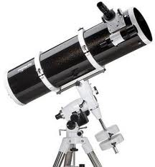
Is the image upright or inverted? _____________________ Does it matter how your head is tilted and which direction is gravity?______________________________

Here is a picture of a real Newtonian Telescope (the same kind as our model).

Before you leave, please put the screen back in place for the next person.

- MICROSCOPY
If you magnify the image from a magnifying glass, you get a microscope. It lets you enter the realm of the small. Plant and animal tissues, blood cells, and microorganisms become visible. Look through the optical microscope we have set up with a slide.

For even further magnification, we developed the electron microscope, which uses a fine beam of electrons in place of light. The electrons are focused by magnets to create the image. Since electrons have a much shorter wavelength than visible light, they can reveal much smaller detail.
- "BENDING" LIGHT TOTAL INTERNAL REFLECTION
Observe the laser beam as it strikes the interface of water and air or plastic and air. Change the angle gradually and 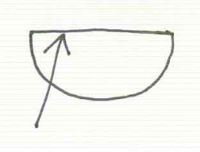see what happens.
Sketch what happens when the beam comes through the water and
hits the air at a steep angle. Show both reflected and refracted rays.
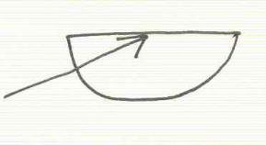
Sketch what happens when the beam comes through the water and
hits the air at a grazing angle.

At what angle does the light first become totally reflected from the surface (none escapes)?

Shine the laser into the various "light pipes." Notice that light beams are always straight until they reflect at a surface. Explain (with a sketch) how a fiber optic is able to "guide" the laser light through the bends. Try all of them!

An optical fiber is a flexible, transparent fiber made by drawing glass or plastic to a diameter close to that of a human hair. Light signals travel along the fiber with essentially no loss, allowing communication over longer distances than electrical cables.

- OPTICAL ILLUSION BANKS-- just for fun
With your lab partners, observe each of the two optical illusion banks. Feed them pennies! The optical illusions are created using mirrors or lenses. Discuss with your lab partners how each illusion might be created, and write (or draw) your ideas below. Then check with the instructor to see if your models are correct

Mandatory comments This is a new lab. Please give us feedback so we can make it better.

