Physics 10L – Rick Nolthenius, Instructor for Fall 26
Your Name _________________________________________

Lab 13: Heat and Thermodynamics
Read Hewitt Chapters 15 to 19
Would you rather be too hot or too cold? One of the first things you need, to survive on our planet, is to be neither too cold or too hot. Then you can worry about food, and all the other stuff.
What is this “heat” thing? It’s just energy, a very important form that we use in countless ways. It is the energy from the Sun that makes life possible on Earth. It runs the machines that do our work.
It’s also where our concentrated forms of chemical energy, like fossil fuels, end up after we use them. Today we will play and learn a bit about heat and how we use it.
The scientific study of heat, entropy (think of it as “disorder”) and other forms of energy, how they can be transformed from one type to another, or “handed off” from one object to another, is called Thermodynamics.
Heat: the energy that transfers from a hot object to a cooler one, measured in joules or calories.
Temperature: the average kinetic energy per molecule of a substance, measured in degrees (Celsius, Kelvin, or Fahrenheit, depending which you’re choosing to use.)
Conduction: heat transfer from particle to particle within a material, or from one material to another when they are in direct contact.
Convection: heat transfer by movement of the substance itself.
Radiation: heat energy transmitted by electromagnetic waves.
(this is different from the ionizing radiation we studied in the radioactivity lab!)
Experiment with the equipment provided to help answer the questions below and other questions of your own. Have fun!
Mandatory Comments
Brand new lab! Use this space for questions and suggestions for improving this lab.

- Heat vs Temperature: Sparklers !
The sparks’ temperature may exceed 2000 degrees Celsius, but they impart very little heat when they strike your skin. This illustrates that heat and temperature are different concepts. Carefully put your hand in the sparks (not the hot tip), what do you observe?

Why would it be dangerous to touch the hot tip itself? The sparks and the metal tip are the same temperature; why is one more dangerous than the other?

A familiar and related phenomenon might be when you open an oven where a cake is baking. The metal racks of the oven, the surface of the cake, and the air in the oven are
all the same temperature. Are they all equally safe or dangerous to touch? Can you explain why?

- Can you trust your senses? Hot and Cold baths
Place the fingertips of one hand in the ice bath and the fingertips of the other hand in the warm bath. Stir them around a little.
After 10 to 15 seconds, put both hands into the middle bath which has room temperature water in it. Again, stir slightly. What do you feel?

What does this tell you about the way your body senses temperature (and for that matter, the way we sense a LOT of things)?

- Sensing heat and cold

This experiment has two copper coils wrapped around a core, with ice water flowing through one, and nice warm water flowing through the other. They are wrapped alternately on the core. Feel the warm water, and the ice water. Then put your hand on the alternating coils.

What surprises you? You know the warm water is NOT hot, but it feels hot next to the ice water. You have tricked your senses!!

“Is very temperature! Danger!!” – the human brain and nervous system.

- Temperature scales Thermometers
“Fahrenheit measures how a human feels. Celsius measures how water feels. Kelvin measures how atoms feel.”- a (possibly biased) smart aleck.
Americans mostly use the Fahrenheit scale, and the rest of the world uses Celsius.
There are advantages to each.
Actually, both systems are just designed for life in the temperate zones and we realize that “zero” is just assigned to a particular spot on the Absolute temperature scale. Absolute Zero is -273.15 C, which is -459.7 F and 0 K.
Look at the thermometers and compare.

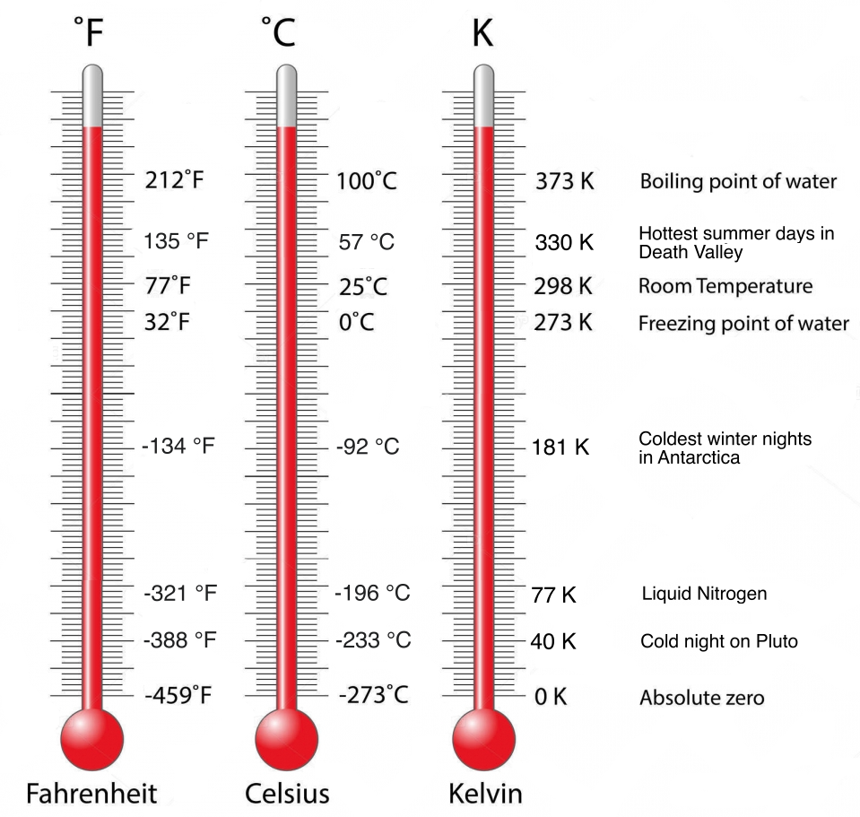

- Heat capacity of water and lead

If we pour 200 grams of lead shot at boiling temperature, 100C, into 200 grams of water at room temperature, 20C, what do you predict will be the final temperature of the mixture?
Record your predictions: ________________
We will do the experiment as a group.

What is the result? Did you make a good guess?

What does this experiment show about lead and water?

Which would you conclude is “easier” to warm up or cool down: lead or water? Why?

Substances which are hard to warm up or cool down have a “high heat capacity”. This may seem backwards, but think about what the word “heat” means... (It’s not the same as temperature.)

- Temperature as Kinetic Energy: compression igniter
The compression tube allows you to very rapidly squeeze air molecules together, causing them to suddenly be moving much faster. If you do it quickly enough, the energy you exerted has no time to flow out of the tube by conduction, so the energy goes right into raising the temperature of the gas – enough to ignite the tiny paper in the tube!

Were you successful?

What common engine (used in some motor vehicles) uses compression to ignite its fuel?

- Conductivity of metals SPIDER
(During this experiment, please do not touch any of the metal pieces once the candle is lit. The metal gets painfully hot quickly!)
The “legs” of the spider are strips of metal, each made of a different type of metal.
A candle flame under the central “hub” of the spider will be the heat source; eventually its heat will melt the wax clumps at the ends of the legs. Before you begin, try to predict which bits of wax will begin to melt first.
Light the candle and record your observations. Rank the thermal conductivities of each metal – that is, how easily each type of metal conducts heat energy.

When done, please cool off the “spider” in water for the next group. (Why does water work well to cool off hot things?)
8. Thermal expansion: Ball in socket

A metal ball is just able to pass through a metal ring. When you increase the temperature of the ball, will it still pass through the ring? What if you leave the ball at room temperature, but increase the temperature of the ring instead? Will the hole become larger, smaller, or stay the same?

Student #1: “When the ring gets hot, it will expand, so the ball will fit through more easily.”
Student #2: “No; when the ring expands, it will squeeze the hole smaller, so the ball will NOT fit the hole.”
Who is right?

- Conduction blocks
Two black blocks at room temperature feel quite different to your warm hands. After you feel them, place a cube of ice on each one. Predict which one will melt the cube of ice more quickly.
What do you observe, and why?

- Work from heat: Stirling Engine
Stirling engines convert heat energy into mechanical work. They use an external source of heat to warm gas, which expands and is pushed into another chamber. When the gas cools and contracts, it flows back. The expansion and contraction pushes a piston. Invented in 1816, these engines are generally more expensive and complex than the internal combustion engines we commonly use today.

This small, quiet engine lets you observe heat being converted directly to work.


- Infrared camera: seeing heat.
At any time, every object around you is glowing with light. We're not talking about the light that an object reflects from its surroundings, but the light that it gives off just by existing at a given temperature. For objects at “reasonable” temperatures – say, room temperature, or human body temperature – this light is entirely infrared. Our eyes cannot see it, but the infrared camera can.
As the temperature of an object rises, two things change about its “glow”: it gives off more light, and the average frequency of that light rises. So the image on your IR camera gives you a visual map of the temperature of objects surrounding you.
Things to investigate with the infrared camera:
- Observe your lab partner using the IR camera. Does human skin radiate thermal energy? How about someone's eyes, or the inside of their mouth when they open it?
- Place your hand on a room-temperature surface like the lab tables. With the IR camera, can you see a higher-temperature handprint?
- Place an ice cube against your arm for a minute or so. Then look at your arm through the IR camera. How long does it take the cold spot to fade?
- When you strike a block of wood with a hammer, where does the hammer's kinetic energy go when it hits the wood? Does the energy disappear? One part of the answer comes from the “BANG” you hear from the hammer blow; sound waves do carry energy. For another piece of the answer, give a wooden board a sharp blow with a hammer, then use the IR camera to examine the spot on the board where the hammer struck. Do you see what form (some of) the hammer's kinetic energy now takes?

