**Directions to Mono Hot Springs And Our Campsite**

The prior map packet I handed out will get you from Santa Cruz up to the Sierra to Kaiser Pass Rd, up and over Kaiser Pass itself (9,000 ft elevation) and then heading down the other side into the San Juaquin River drainage. You’ll be driving through granite outcrops, pines, and generally rugged but beautiful country for a few miles. You’ll see a small lake on your left “Portal Forebay”, about halfway to your next turn, and you’ll also pass a Ranger station in a wooded area. It’s roughly 10 miles from Kaiser Pass to the left turn (see map) which is Edison Lake Rd. and which you need to take to get to Mono Hot Springs. Then it’s about 1.7 miles to another left turn “T” intersection which goes steeply downhill to Mono Hot Springs Resort about a ¼ mile further down. **This “T” intersection is where I will have a cardboard box labelled “Cabrillo” and in that box will be a bunch of map photo copies.** Take one, it will have our campsite shown on it.

On the second map, I’m going to label possible spots that I think might be usable, but since I can’t do “street view” it’s very hard to see where we can actually pull off the road. There’s a lot of granite around and that makes going off the road limited near Mono Hot Springs itself. That is also the map that I’ll reproduce and put more definitively where we actually are, once we (I? Kirk B?) arrive and make that decision. I don’t know right now which of these spots we’ll end up at, so I’m showing you all of them.

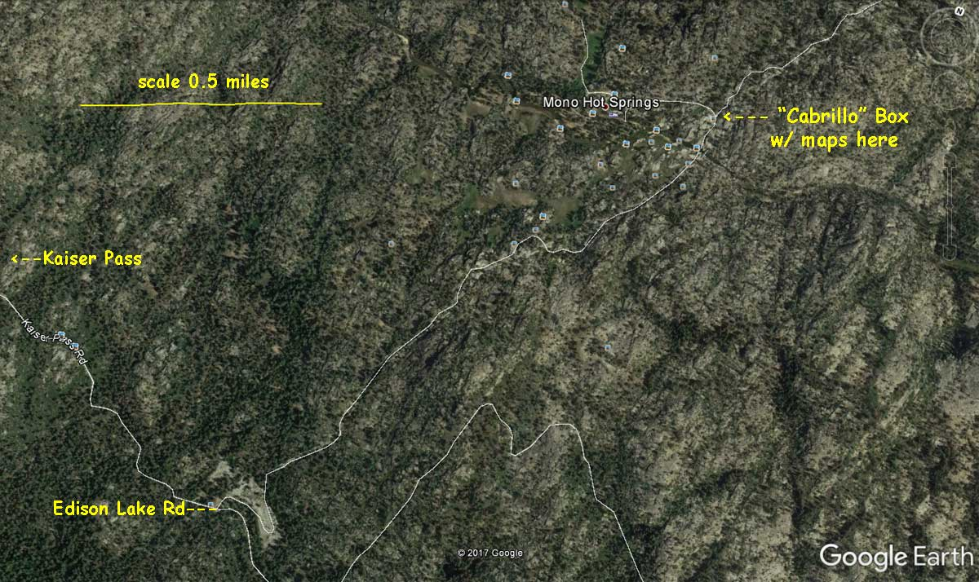

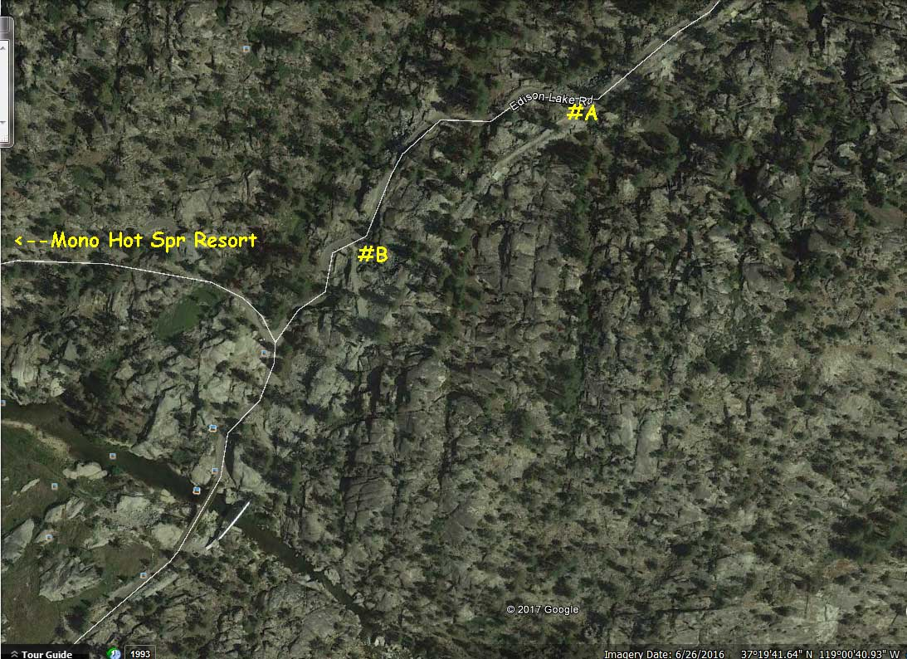

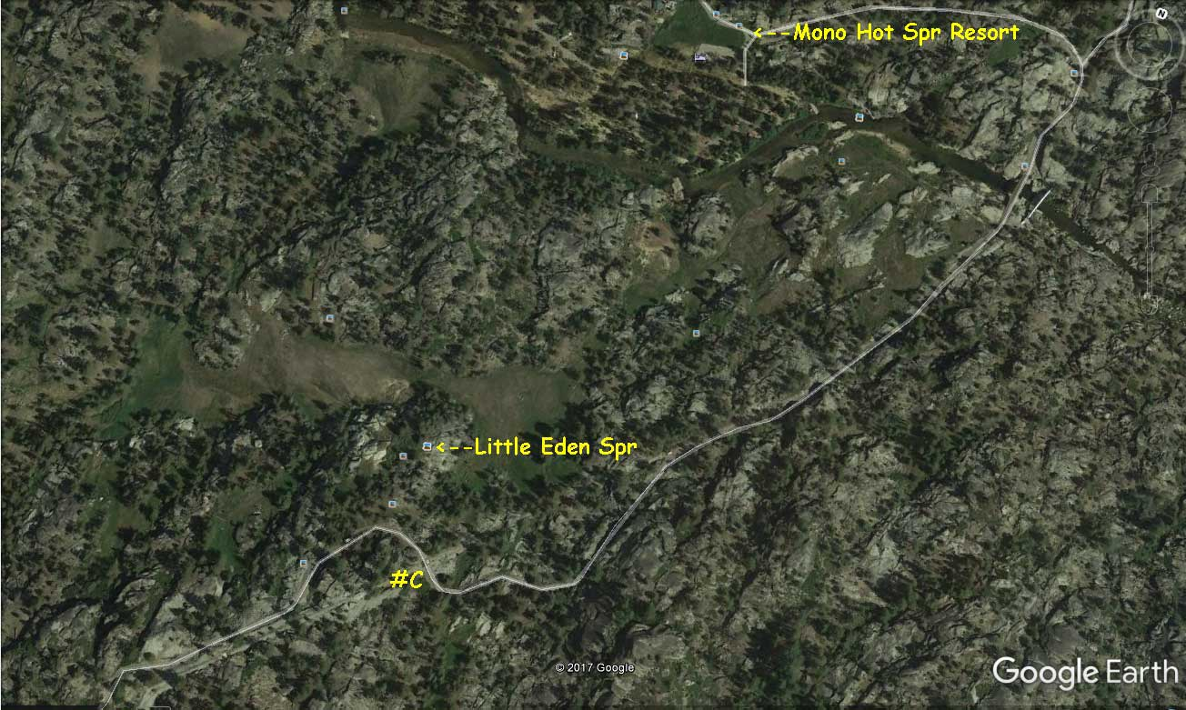

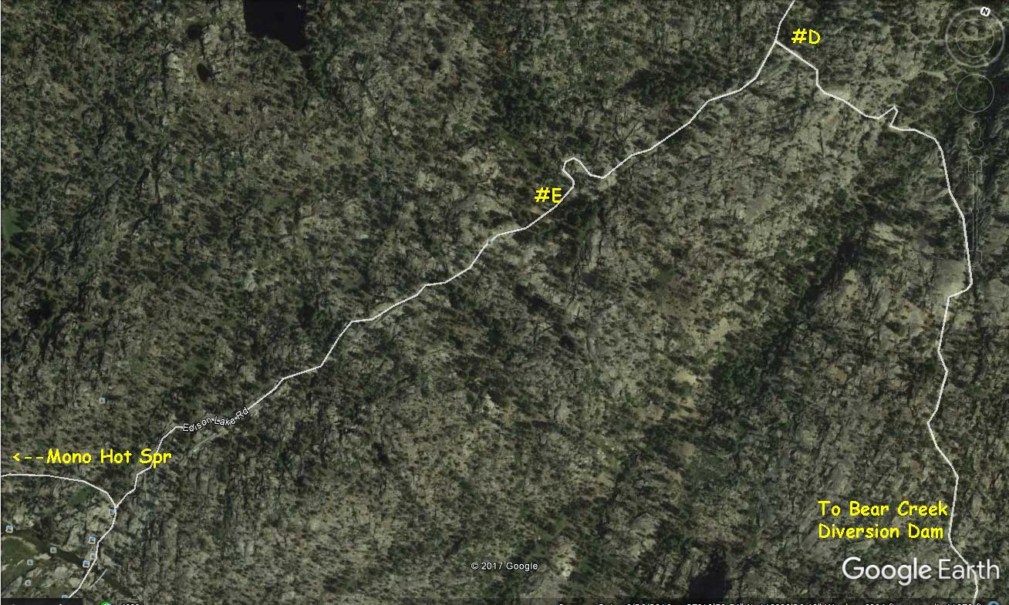

Site #I in most ways is the most desirable… close to the resort and the hot springs. But I’m worried about one little spot in the road that might be hard for some cars to get over. It’s a 2-track dirt road which is no problem except for that one spot. We’ll discuss on Saturday July 15 after I see what vehicles will be coming. Now, the other hard thing about site #I is that it is usually occupied. The others, less likely.

