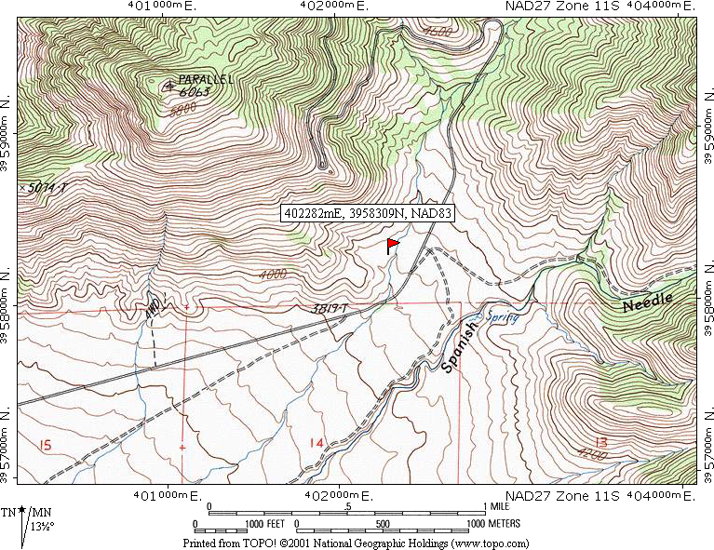

From SR14, south of the turn-off to Inyokern, take SR 178 west for about 17 miles.

Turn right on a road marked “Chimney Peak”; the road is initially paved but quickly becomes graded dirt. Proceed about 2.5 miles on this road and park.

The site is a large (house-size) grano-diorite boulder to the west of the road, on the west side of a deep dry wash. There are faint pictographs on the east side of the boulder, and local Native Americans claim it is a solstice site.

Just west of the site is a trail leading approximately north. If you follow that trail about a quarter mile it comes to another site, in a small overhand and concealed behind a tree. It too appears to be a solstice site; the paint is much brighter on this boulder, since it is more protected from the elements.

